Welcome Club

April 23 2021~ 3:30pm-4:30pm

 Character lesson of the month:

Integrity- doing what’s right even when no one is watching

* Accepting consequences

**3:30-3:35**

Introduction to Welcome Club  - (Coach Amy)

-Build friendships

-Help each other

-Discuss problems and issues with coaches and students

-Have fun!

 *Review Welcome club’s foundation for how we treat each other: Treat others the way you want to be treated.

-**Transition**- (Coach DeVon) “Ok let’s have the coaches introduce themselves and tell us what is your favorite candy?”

**3:35-3:45**

 Introduction of Coaches- We will take turns sharing our name and sharing your favorite candy.

-**Transition**- (Coach Becca) “Now I want to introduce our lesson for today.”  Accepting consequences as a part of integrity

Introduction of Character Lesson- “Today we are going to talk about integrity and consequences.

-**Transition**- (Coach Dani) “Let’s get into our breakout rooms and we can start with a game! Everyone make sure you have your Welcome Club bag.”

**3:45-3:55**

- Coaches, start your group time by having each student introduce himself or herself and share what candy they feel like today. Next, you will need to explain the rules of the game. Assistant coaches are encouraged to participate.

ICEBREAKERS  - Paper plate drawing challenge

Directions: using a paper plate, students will attempt to draw a figure without looking. Place paper plate on head and draw item described by coaches. Example: teacher, house, car, American flag, flowers, zoom meeting

**-Transition-** (coaches) “Remember what Coach Becca said about integrity? We are going to talk more about integrity and consequences”.

**3:55-4:15**

 Lesson:    Integrity- Consequences

Coaches:

“Who can tell me what happens when you throw a ball up in the air? What happens to the ball? Where does it go? Does it fall back down? Yes! That is the same with consequences. *Consequences are the result of an action*. When you act, like when you drop a pencil, the result is the pencil falling to the ground. Everyone try it. Get your pencil or something from your goody bag. Drop it and see what the consequence is. Some consequences are really good. Who can give me an example of a good consequence? Some consequences are hard. Who can give me an example of a hard/bad consequence? We learned last time at Welcome Club that integrity is doing what is right even when no one is watching. How can we have integrity- doing what is right- when we have to accept consequences?

What about when our mom tells us to help clean the house while she is at the store? What would the consequences be if we clean? What will the consequences be if we don’t clean? How can we have integrity?

*Give time for students to discuss.* When we have integrity, how does that affect our consequences? *Give students time to discuss.*

**Transition**- “We are going to make a paper helicopter today. This can help us remember consequences”.

**4:15-4:30 Activity- Paper flutter helicopter**

<https://www.pinterest.com/pin/679902874986851577/>

Students will take strip of paper and glue the two ends together with glue stick. Making a circle with a small handle like a balloon shape.

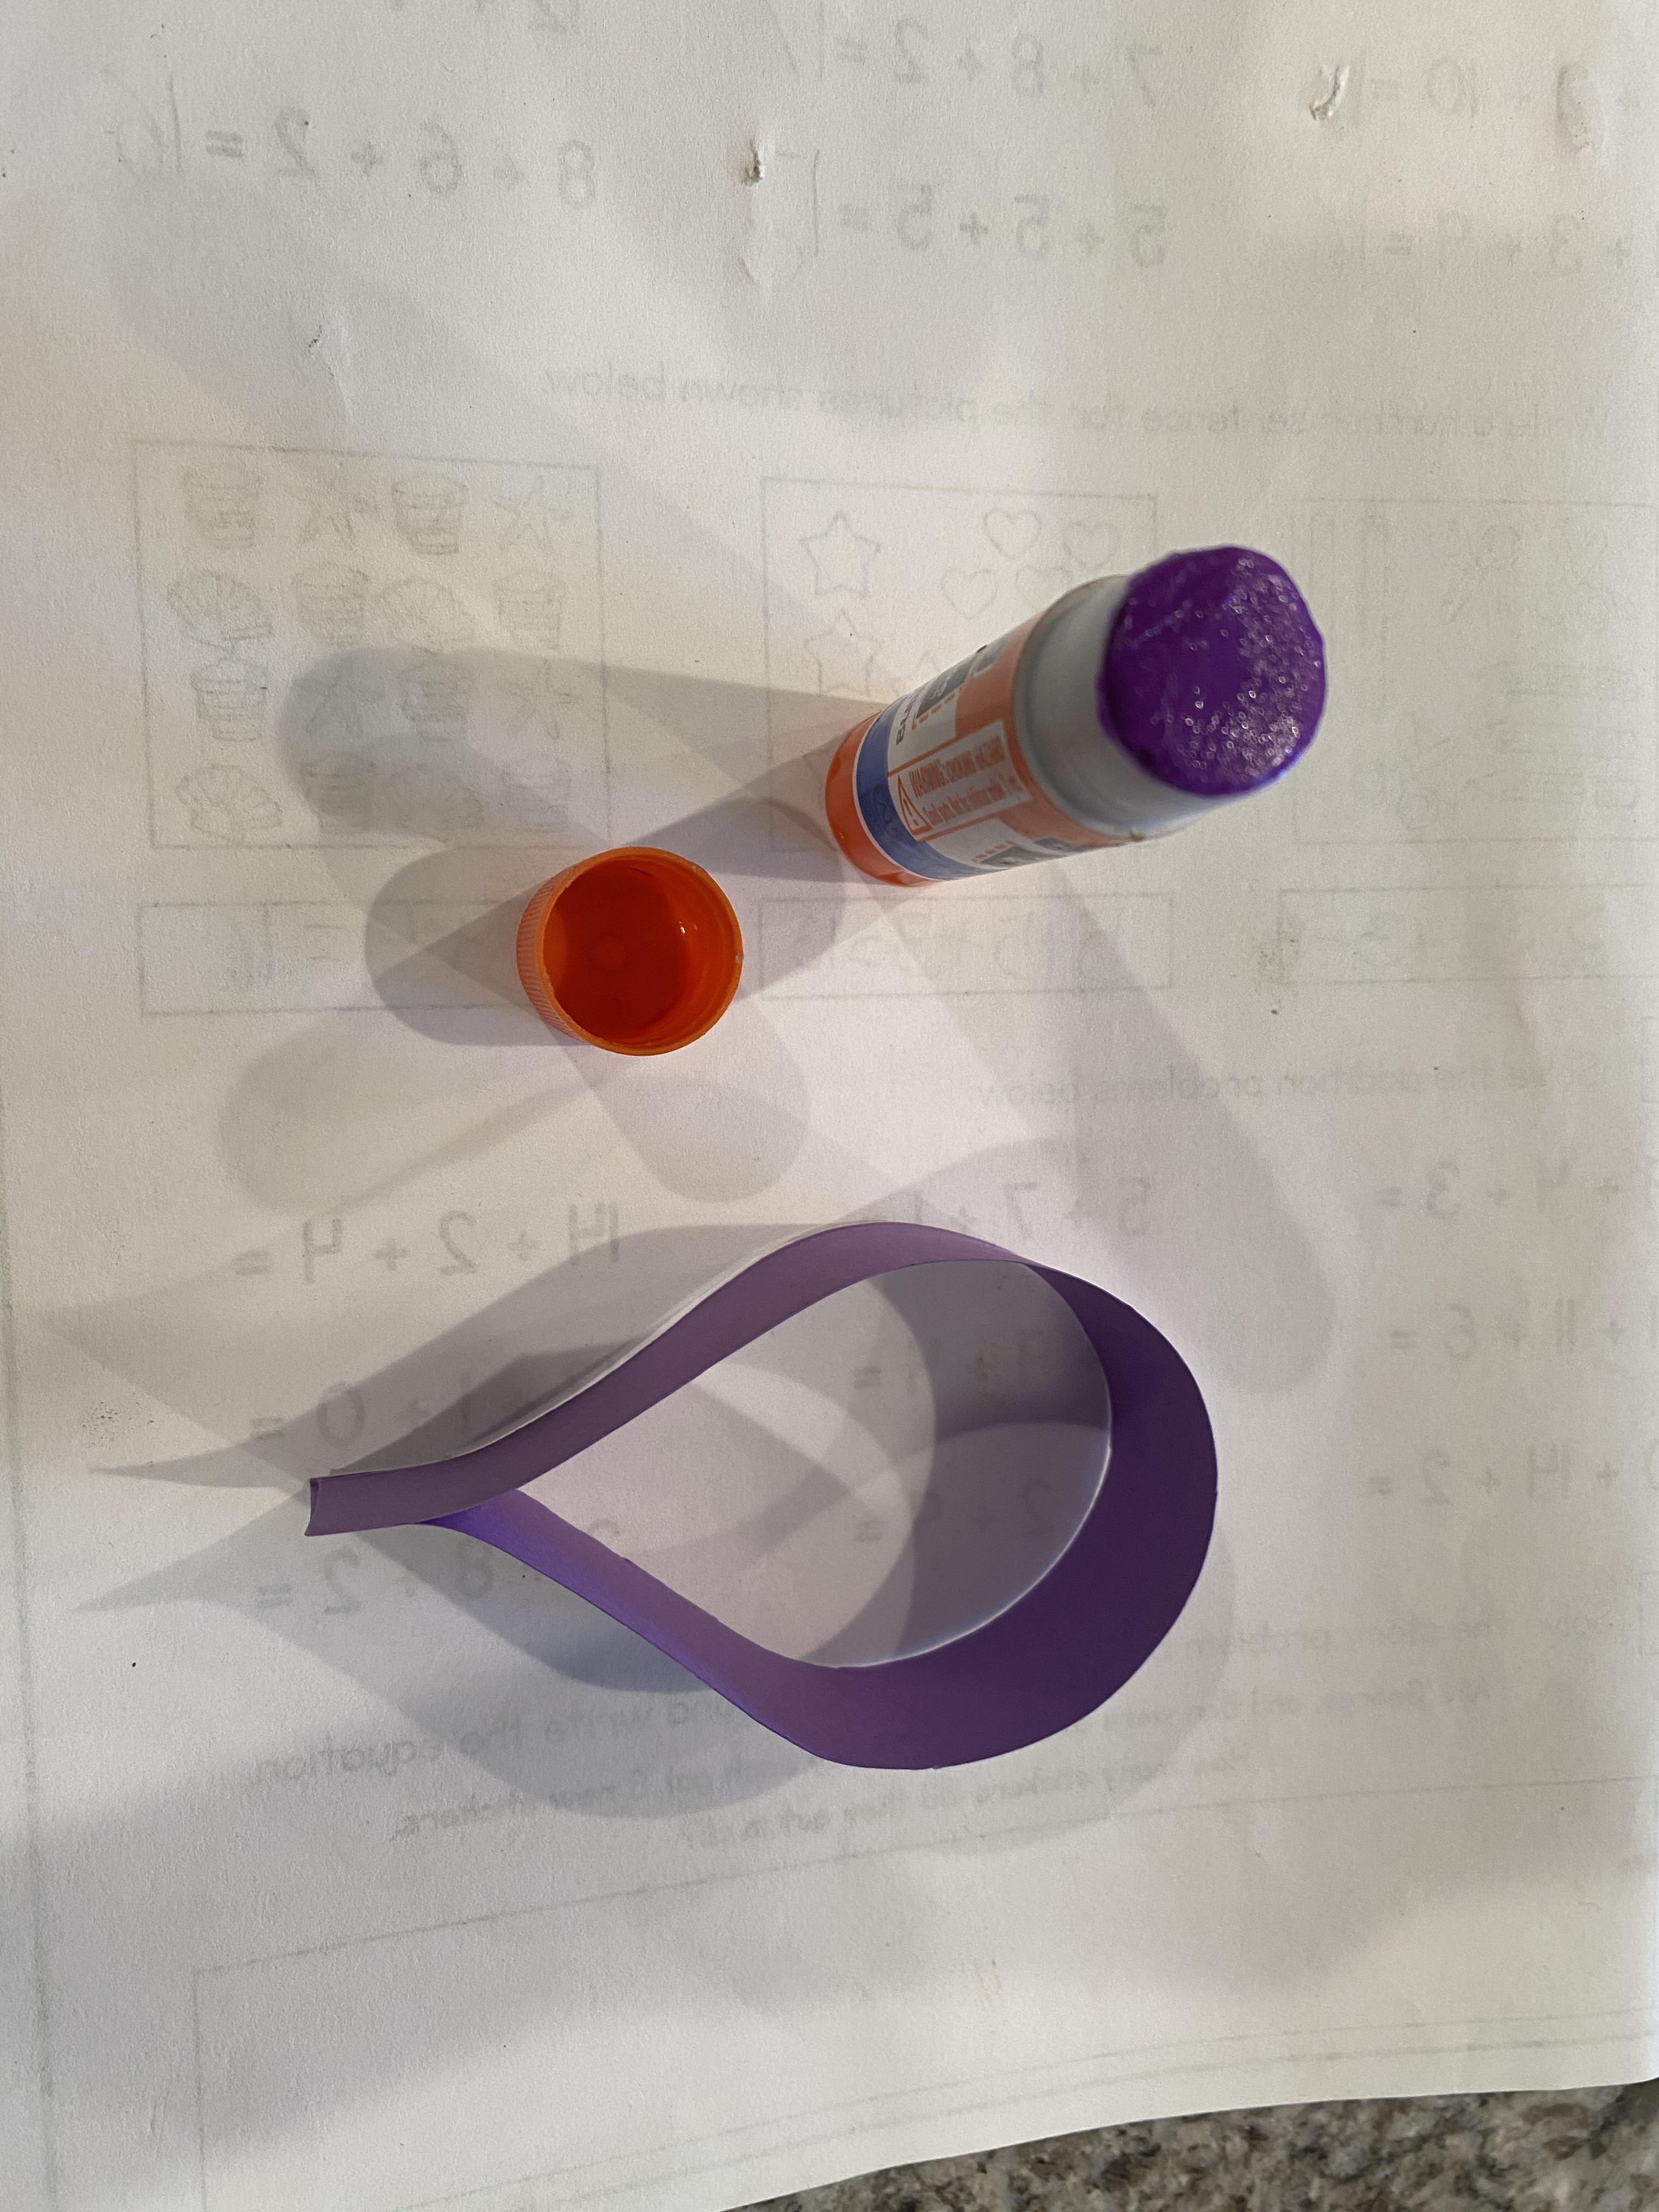

Next, glue the top, under side middle to the middle of the top of the bottom part of the circle, making the balloon shape squished into a wing shape.

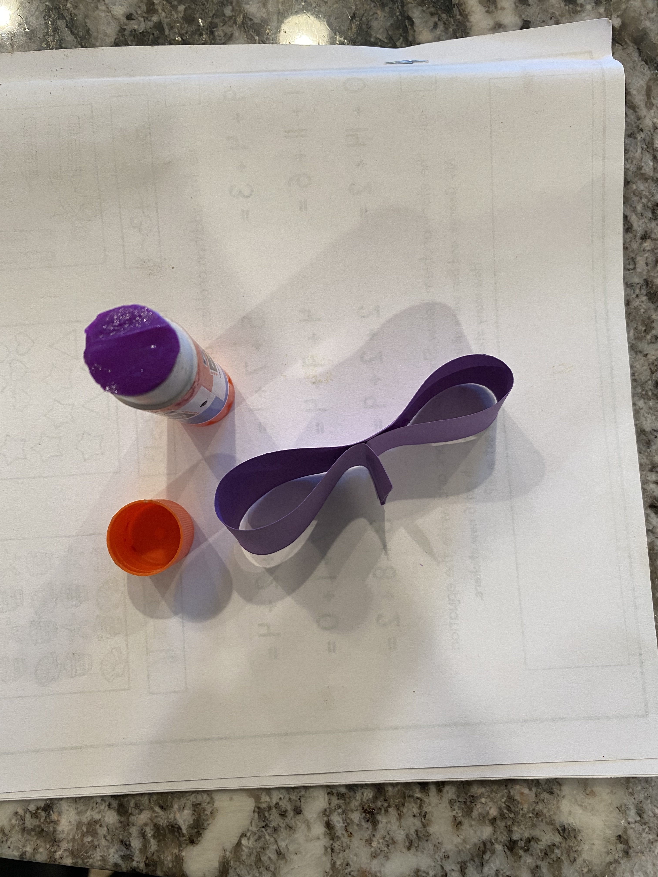

Try out the paper flutter helicopter. Does it work? How high does it go? Does it go straight down? How does it move?

Conversation starters and fun question ideas- Would you rather….

1. Would you rather make funny sounds all of the time or would you rather have a tree growing out of your head?
2. Would you rather have webbed feet or webbed hands?
3. Would you rather have rainbow colored skin or a voice that sings every time you speak?
4. Would you rather have a body that is shaped like a candy cane or shaped like a lollipop?
5. Would you rather turn into a purple bear or a heart shaped pillow every time you felt happy?
6. Would you rather only be able to get around by bouncing like a kangaroo or leaping like a ballerina?
7. Would you rather only be able to eat food that is red or only be able to eat food that is green?
8. Would you rather have four arms or four legs?
9. Would you rather eat donuts or candy every day?
10. Would you rather eat only chocolate or only vanilla food?
11. Would you rather be a scientist or an artist?
12. Would you rather travel to every continent or only get to travel to your favorite place once a year for the rest of your life?
13. Would you rather spend the day at the museum of your choice or spend the day at the store of your choice?

**4:30**

 Wrap up and Goodbyes

* Updates and information- (Coach Makayla)
* Tutoring- Thursday 2:30pm  Reading pod- Monday 3:30(Coach Megan/Makayla)

**\*Coaches stay on for quick debrief**

**Bag contents:**

Snack

Drink

Activity Sheets

Paper strips

Glue stick/double sided stickers

6-8 Paper plates